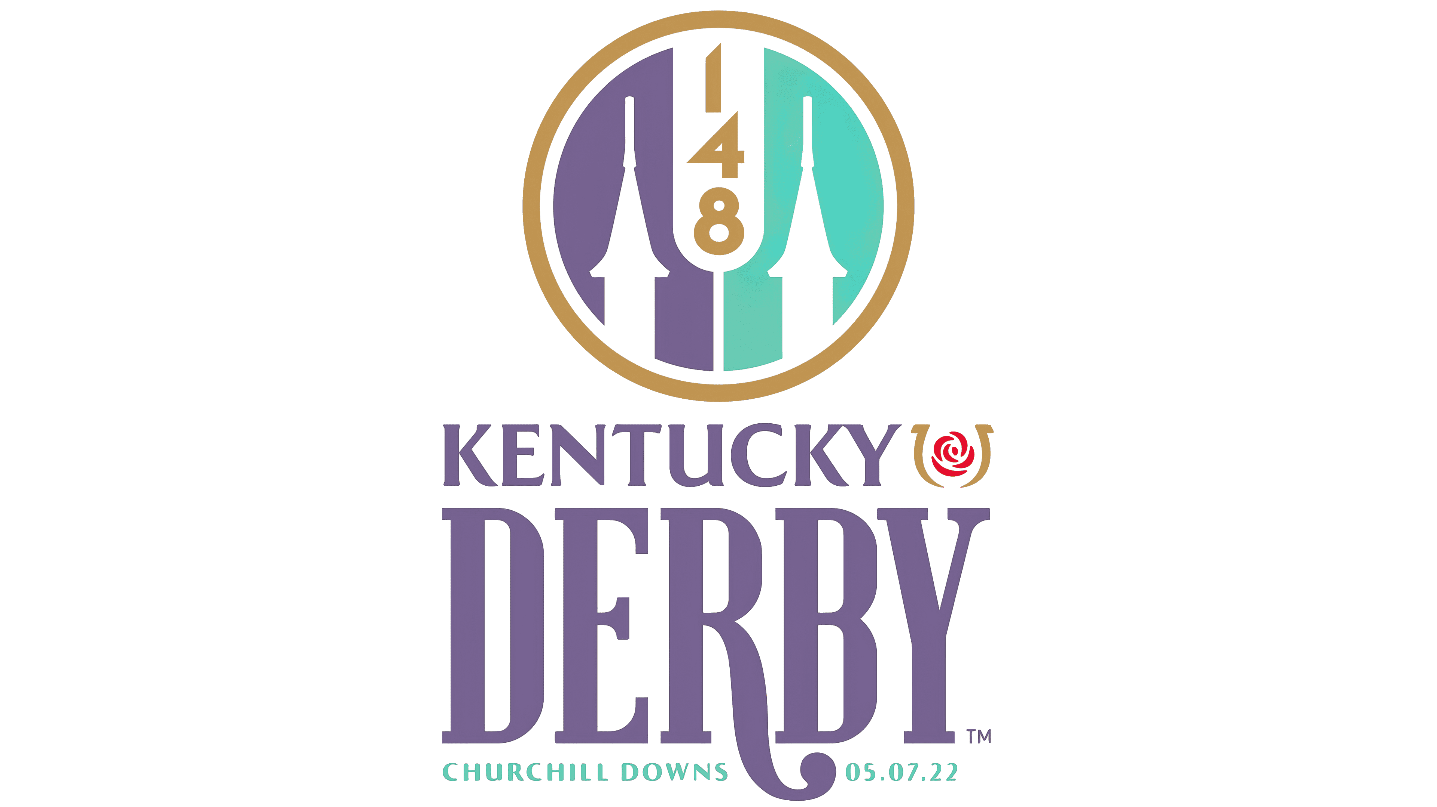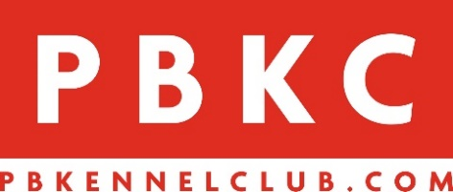

WELCOME TO PBKC & KENTUCKY DERBY DAY - SAT., MAY 7TH
KENTUCKY DERBY SOUVENIR GLASS - $5
KENTUCKY DERBY T-SHIRTS & HATS AVAILABLE AT INFORMATION CENTERS
Kentucky Derby Fest at PBKC - The Best Party South of Churchill Downs - Watch, Wager and
Win on the Run for the Roses and enjoy our biggest party of the year.
9:30AM - PBKC Gates & Mutuel Windows Open/10:30AM Churchill Post Time
12PM - Trackside BBQ & Bars Open, Big Screen TVs on track
12PM - Food Trucks Open
12PM to 3PM – Music by Sippin’ Fire
12:30PM to 2:30PM - 95.9 True Oldies Handicapping Contest
2:30PM to 5:30PM - Balloon Artist Karl Koppertop / Ace the Poker Bear
3PM to 3:45PM - Kentucky Derby Hat Contest with Virginia from the KVJ Show
3PM to 5PM - Radio Remote with 97.9 WRMF
3:30PM to 6:30PM - Face Painting by Pinky the Clown
4PM to 8PM – Music by Spred the Dub
*Advance wager on the Kentucky Derby Friday, May 6
*Paddock Restaurant Derby Tickets $40 (includes lunch) 561-683-2222, x199
*Purchase official Kentucky Derby Souvenirs & Mint Juleps w/souvenir glass
*Kentucky Derby post time (approximate) - 6:57pm

