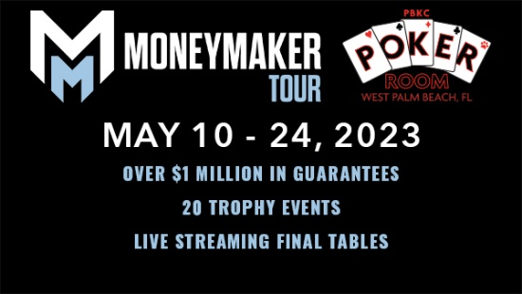

MONEYMAKER TOUR PARTNER HOTEL RATES

HOLIDAY INN PALM BEACH AIRPORT - $124 A NIGHT plus tax
(Must book before April 19)
1301 Belvedere Road, WPB, FL 33405
Contact- Terry Sam (561)659-3880 x 4145
Website: hipalmbeachairport.com
Booking Link- Money Maker Tour Palm Beach Kennel Club

BEST WESTERN PALM BEACH LAKES - $115 A NIGHT plus tax
1800 Palm Beach Lakes Blvd, West Palm Beach, FL 33401
Contact- Rick Netzel (561) 683-8810
Website:
https://www.bestwestern.com/en_US/book/hotels-in-west-palm-beach/best-western-palm-beach-lakes/propertyCode.10225.html
Booking Link-MoneymakerTourBestWestern

HILTON PALM BEACH AIRPORT $179 A NIGHT plus tax
(Must book before April 19) May 16-20 are unavailable.
150 Australia Ave, West Palm Beach, FL 33406
Contact- Dana Wilson (561) 472-9319
Website: https://www.hilton.com/en/hotels/pbiahhf-hilton-palm-beach-airport/rooms/
Booking Link (1) 5.10.23-5.17.23
MoneymakerTourHilton5/10-5/17
Booking Link (2) 5.21.23-5.25.23
MoneymakerTourHilton5/21-5/25

HOME2 SUITES BY HILTON WEST PALM BEACH AIRPORT - $179 A NIGHT plus tax
(Must book before April 26)
2375 James L Turnage Blvd, West Palm Beach, FL 33406
Contact- Danielle 561-686-1006
Website: https://www.hilton.com/en/hotels/pbiarht-home2-suites-west-palm-beach-airport/
Booking Link:MoneymakerTourHome2Suites

CANOPY WEST PALM BEACH DOWNTOWN – 20% OFF
380 TRINITY PLACE, WEST PALM BEACH, FL 33401
RESERVATIONS: 561-655-0404
Mention Palm Beach Kennel Club when booking room.
WEBSITE: www.westpalmbeachdowntown.canopybyhilton.com
Booking link: 20%OFFCanopyWPB

